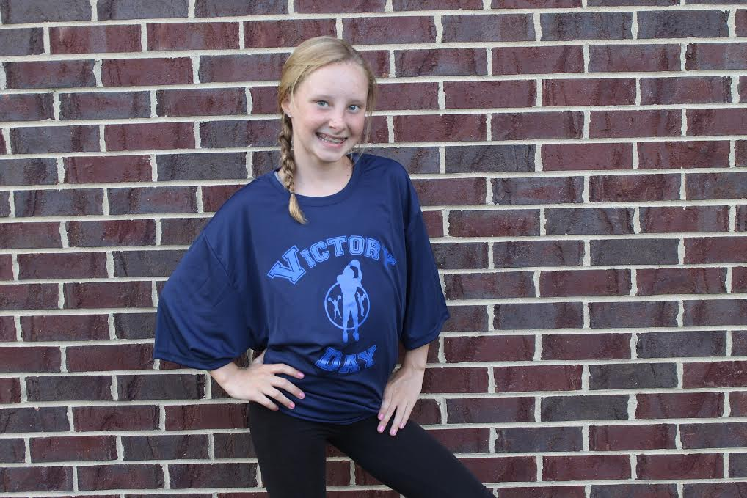
#VD 1501 Fan or Player Jersey
• Body: 3.4 oz., 100% polyester mesh
• Trim: 4.9 oz., 100% polyester dazzle
• Moisture wicking, odor resistant and stain release
• Mesh body with dazzle sleeves and yoke

#VD 1501
Choose a Color: Black, Forest, Navy, Pink, Royal, Scarlett or White
Fan or Player Jersey at $38.00 with Victory Day - add $5.00 for number
__________________________________________________________________________________
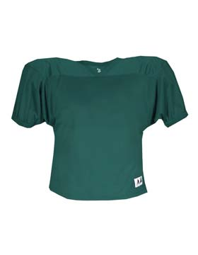#VD 1502 Badger 9484 Victory Day Badger Practice Jersey• 100% polyester porthole mesh body
• 100% polyester dazzle yoke and sleeves Choose a Color: Black, Forest, Maroon, Navy, Purple, Red,
• 100% polyester rib knit collar Royal, Gold or White
• Double mesh yoke • Cover stitched seams • Waist length • Double-needle bottom hem
Practice Jersey/$50.00 with Victory Day – add $5.00 for number
________________________________________________________________________________________
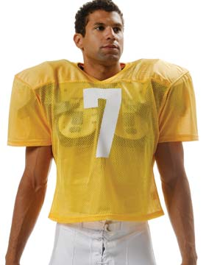
#VD 1503 Practice Jersey
• Body: 5.9 oz., 100% polyester warp knit • Trim: 5.3 oz., 100% polyester mesh • Moisture wicking, odor resistant and stain release • Double-layer yoke • V-neck 1 x 1 knit trim • Reinforced cover seam finish
#VD 1503
Choose a color; Black;Cardinal;Gold;Hunter;Maroon;Navy;Purple;Royal;Scarlet;White
Practice Jersey/ $36.00 with Victory Day – add $5.00 for number
____________________________________________________________________________________

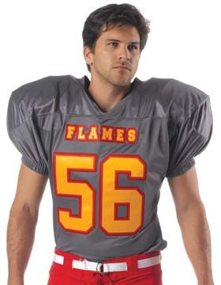
#VD 1504 Game Jersey
• Body: 5.3 oz., 100% polyester mesh • Side Panels and Neck: 16.0 oz., 88% nylon / 12% spandex
• Moisture wicking, odor resistant and stain release • Double-layer yoke • V-neck trim in nylon / spandex fabric
• Sleeve cuff finished with covered elastic #VD 1504Choose a Color: Black;Cardinal;Gold;Graphite;Hunter;Maroon;Navy;Purple;Royal;Scarlet;Gold;White
Game Jersey $52.00 with Victory Day – add $5.00 for number______________
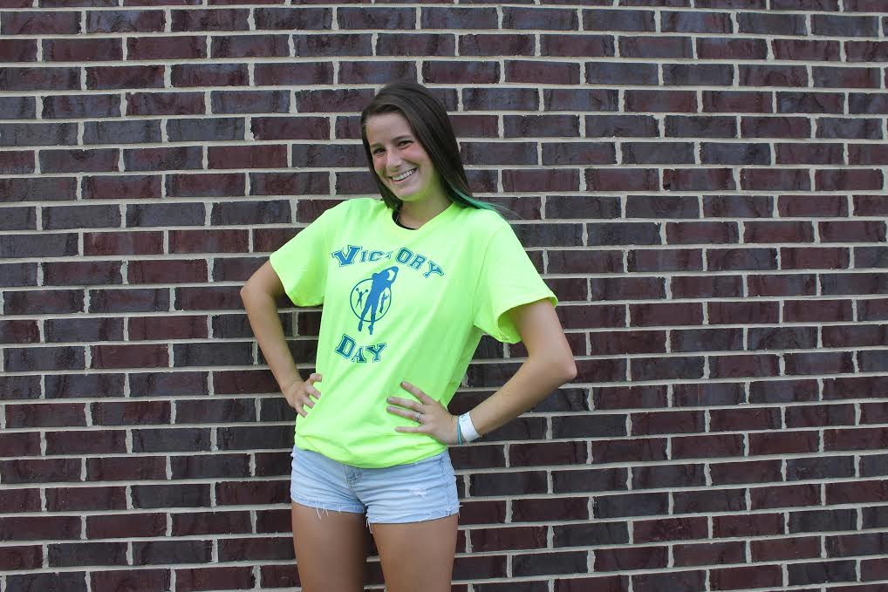

#VD 1505 T-shirt with Victory Day logo - athletic grey for $12
#VD 1506 Hi-Vis safety green w/logo for $15.00

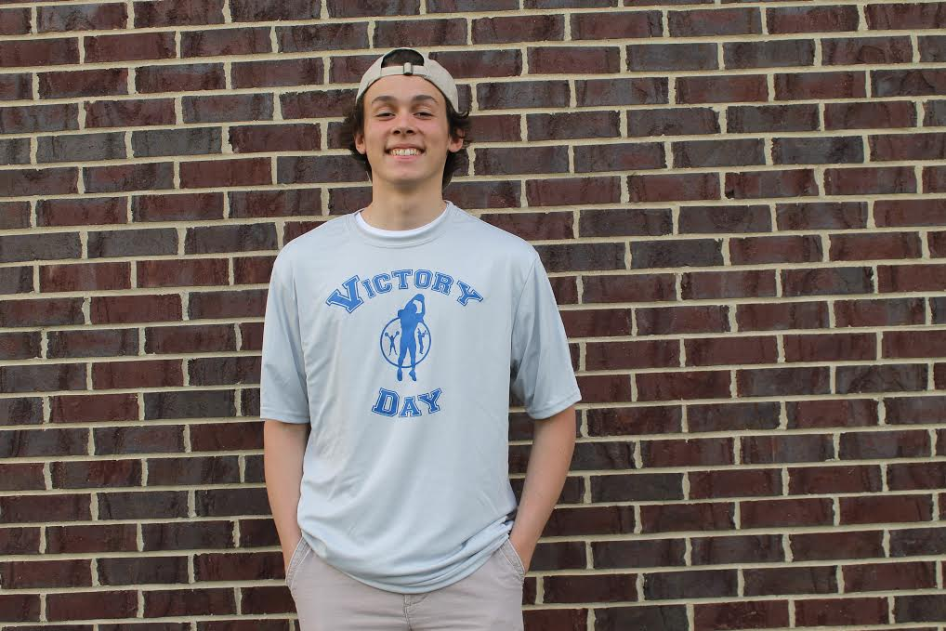

#VD 1507 Moisture Wicking T-shirt w/logo for $18.00 Available in light grey or Dark grey
2xl add $2 ea. 3xl add $3 ea.
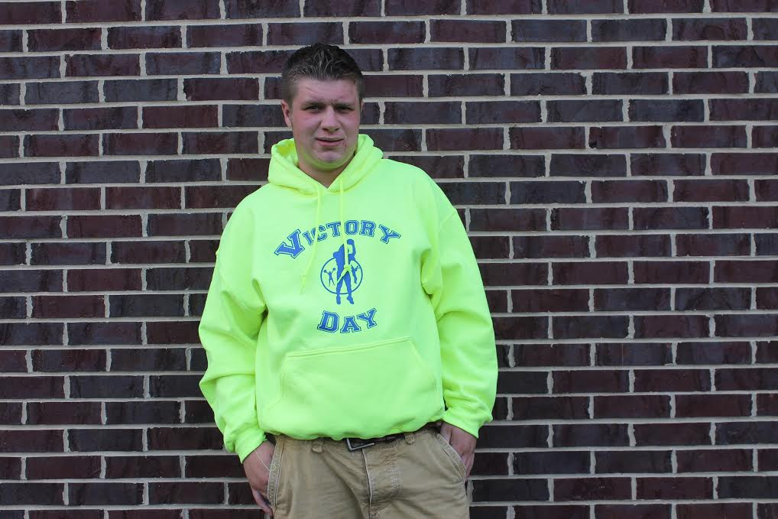
#VD1508 Hoodie Sweatshirt with Victory Day logo, athletic grey for $28.00
#VD1509 Hi-Vis Safety Green for $35.00
2xl add $2.50 ea. 3xl add $3.50 ea.

#VD1510 Knit golf shirt with embroidered logo-standard colors $29.50. Ea.
#VD1511 Knit golf shirt with embroidered logo-safety green $34.00. Ea.
2xl add $2.50

#VD1512 Victory Day medal with ribbon and logo on it for $3.50 ea.
Victory Day Football ORDER FORM
4588 Dolores Dr.
Trenton, MI 48183 Date
Email: segedia@trentonschools.com
www.victorydayfootball.com

BILL TO SHIP TO
Name______________________________________ Name______________________________________
Address____________________________________ Address____________________________________
City, St. Zip________________________________ City, St. Zip________________________________
Phone_____________________________________ Phone_____________________________________
Email_____________________________________ Email_____________________________________

MINIMUM ORDER FOR JERSEES IS 12 PIECES PER STYLE AND COLOR
Item # Description Size Color Quantity Unit Price Total
Sub-Total _________
Please Make Check or Money Order Sales Tax 6% _________
Payable to S&H _________
Other _________
Victory Day Football Total _________

Shipping and Handling
Orders totaling 2 pieces or less $6.50
Orders totaling 3-5 pieces $7.50
Orders totaling 6-11 pieces $9.50
Orders totaling 12 pieces or more $1.00 per piece

Thank You for your order
And Thank You for supporting
VICTORY DAY FOOTBALL

