

Victory Day 2016 at Trenton High

VICTORYDAYFOOTBALL.COM

v

School

Checks payable to:   
**Victory Day**

**4588 Dolores st   
Trenton, MI 48183**  
Return check & this form in the enclosed envelope by:  
***Monday, June 27***

**Victory Day is a non-profit group**

**Tax ID 46-5163137**



SPONSORSHIP LEVELS Super Bowl – $500- $1000 or more * Company name / logo on a banner /lawn sign  
* 20-second announcements on loud speaker during game  
* Pre-game on-field photo with Coach Aaron Segedi   
 (and Lloyd Carr or other special guest)  
* Certificate of Appreciation from Coach Aaron Segedi  
* Name / logo / link on victorydayfootball.com  
* Name / logo in Commemorative Program  
  
Touchdown -- $250   
* Company name / logo on a banner  
* Certificate of Appreciation from Coach Aaron Segedi  
* Name / logo / link on victorydayfootball.com  
* Name / logo in Commemorative Program

**Field Goal – $100**  
* Certificate of Appreciation from Coach Aaron Segedi

* Name / logo / link on victorydayfootball.com

* Name listed in Commemorative Program

**Safety – $50**   
* Name listed in Commemorative Program

*Name/logo/link on victorydayfootball.com

**Extra Point – $20**  
* Name listed in Commemorativ**e** Program

Continue flyer text here. Continue flyer text here. Continue flyer text here. Continue flyer text here. Continue flyer text here. Continue flyer text here. Continue flyer text here. Continue flyer text here. Continue flyer text here. Continue flyer text here. Continue flyer text here. Continue flyer text here. Continue flyer text here. Continue flyer text here. Continue flyer text here. Continue flyer text here. Continue flyer text here. Continue flyer text here. Continue flyer text here. Continue flyer text here. Continue flyer text here. Continue flyer text here.

Continue flyer text here. Continue flyer text here. Continue flyer text here. Continue flyer text here. Continue flyer text here. Continue flyer text here. Continue flyer text here. Continue flyer text here. Continue flyer text here. Continue flyer text here.

Continue flyer text here. Continue flyer text here. Continue flyer text here. Continue flyer text here. Continue flyer text here. Continue flyer text here. Continue flyer text here. Continue flyer text here.

SPONSOR FORM / HELPFUL INFORMATION

• Sponsors are welcomed to participate in   
Victory Day activities (volunteers, cheer support in the crowd, etc.) at Trenton High School on   
**Saturday, September 10th**. An email will be sent in   
August with more specific details.

• NAME:______________________________________

• COMPANY NAME:____________________________

• WEB ADDRESS:______________________________

• MAILING ADDRESS:__________________________

• PHONE:____________________________________

• EMAIL:**_____________________________________**

• For more information visit VictoryDayFootball.com or contact **Renee Emery, Director, Victory Day Sponsorship at 734-624-2526 mom3times@ymail.com**

Thank You for your interest in supporting   
Victory Day! Please join me and members of our community to give kids with Special Needs and their families a day of encouragement and fun on the football field. I promise you, it will be a memory that you will never forget!

-- Coach Aaron Segedi  
 Founder, Victory Day



PLACE PHOTO HERE,

OTHERWISE DELETE BOX



Dear

**Victory Day** is an afternoon of education, inspiration and fun on the gridiron for cognitively and physically impaired children in the Downriver area. These Special Needs participants are provided with a full “game day experience” and have the opportunity to play football, cheer on the squad or march with the band while their parents, family members, caregivers and teachers witness the realization of a dream coming true for their child or friend.   
The event is hosted by the Trenton High School (THS) Varsity Football Team, the THS Cheer Team and the THS Marching Band.

Financial support from local and corporate businesses helps our organization grow, and the resources raised will impact the lives of those who need extra support and encouragement.

**Victory Day’s** core principles, past participation and positive community feedback has garnered local and national media attention, including interest from top high school athletic programs from across the United States that want to replicate its success.

Founded in 2010 by **Aaron Segedi**, a Riverview native, current Trenton 7th grade Science teacher and Varsity Football Defensive Coordinator, is a three-time cancer survivor. He strongly believes that building character holds equal importance to teaching his students – the next generation of leaders – the game-winning plays and lessons they will need to embody and embrace both on and off the football field. Coach Segedi creates a positive learning environment and helps individuals with similar goals by “inspiring leadership and instilling courage” through volunteerism and mentorship, often resulting in life-long friendships and a commitment to community service.

Thank you for your time and consideration. Attached is a **Victory Day** Sponsorship Form for your review. We look forward to your ongoing support!

Continue flyer text here. Continue flyer text here. Continue flyer text here. Continue flyer text here. Continue flyer text here. Continue flyer text here. Continue flyer text here. Continue flyer text here. Continue flyer text here. Continue flyer text here. Continue flyer text here. Continue flyer text here.

Continue flyer text here. Continue flyer text here. Continue flyer text here. Continue flyer text here. Continue flyer text here. Continue flyer text here. Continue flyer text here. Continue flyer text here. Continue flyer text here. Continue flyer text here. Continue flyer text here. Continue flyer text here. Continue flyer text here. Continue flyer text here. Continue flyer text here. Continue flyer text here. Continue flyer text here. Continue flyer text here. Continue flyer text here.

Continue flyer text here. Continue flyer text here. Continue flyer text here. Continue flyer text here. Continue flyer text here. Continue flyer text here. Continue flyer text here. Continue flyer text here. Continue flyer text here. Continue flyer text here. Continue flyer text here. Continue flyer text here. Continue flyer text here. Continue flyer text here. Continue flyer text here. Continue flyer text here. Continue flyer text here. Continue flyer text here. Continue flyer text here. Continue flyer text here. Continue flyer text here. Continue flyer text here. Continue flyer text here. Continue flyer text here. Continue flyer text here. Continue flyer text here. Continue flyer text here. Continue flyer text here. Continue flyer text here. Continue flyer text here. Continue flyer text here. Continue flyer text here. Continue flyer text here.

*Two young adults from two different worlds came together at Victory Day and helped each other realize the value of football and friendship.*

Victory Day at Trenton High School

4588 DOLORES DR

Trenton, MI 48183  
P: 734.552-4654 (Coach Segedi – cell)

E: [segedia@trentonschools.com](mailto:segedia@trentonschools.com)

P: 734-624-2526 (Renee Emery – cell )

E: Mom3times@ymail.com

**www.victorydayfootball.com**

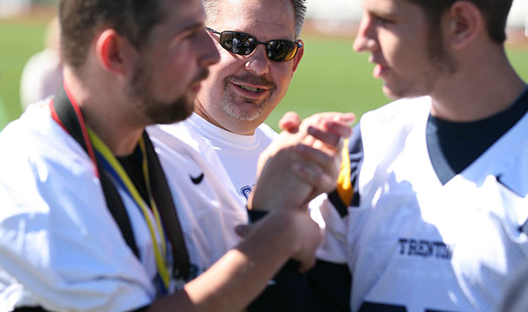

PLACE PHOTO HERE,

OTHERWISE DELETE BOX

Victory Day 2016 at Trenton High School